Physical Diagnosis 2 · Exam 1 — Study Guide
Editable Word copy of the PA_Quizzes study aid. Headings use real Word styles, so the navigation pane and the contents field below both work, and restyling one heading restyles them all.
[In Word: right-click here and choose Update Field to build the contents.]

1 · Clinical Reasoning, Documentation & the Encounter
INSTRUCTIONAL OBJECTIVES
Topic Outline: Application of Clinical Reasoning and Problem-Solving Abilities and Effective Exchange of Information
- Describe the format and components of a comprehensive patient history and physical examination to enhance clinical reasoning.
- Describe the role of small groups and simulations in fostering clinical reasoning and problem-solving skills.
- Discuss the application of clinical reasoning in crafting oral presentations that accurately reflect patient care scenarios.
- Discuss the importance of clinical reasoning during an Objective Structured Clinical Examination (OSCE).
- Differentiate between a comprehensive and focused patient history and physical examination.
- Differentiate between the documentation of a complete history and physical examination and a problem-focused subjective-objective assessment and plan (SOAP).
- Demonstrate documentation of a complete history and physical examination.
- Explain the importance in involving the patient in healthcare communication.

NOTE
Where this material actually lives. Objectives (a), (e), (f) and (g) are documentation objectives, and the Lecture 1 deck does not teach them — it assumes you carry them forward from Physical Diagnosis I, and says so directly: review the documentation content from PD I. They are answered below, and the PD I Exam 3 guide covers the same ground section by section if you want the long version.

1.1 · Objective a — Format and components of the comprehensive history and physical
A comprehensive history and physical is the full record of an encounter, taken in a fixed order so that nothing is lost and so that anyone reading it later finds each piece where they expect it. The components, in the order they are gathered and written:
Component | What it holds
Chief complaint | Why the patient came, in their own words where possible
History of present illness | The narrative of the current problem, built from the seven attributes of a symptom
Past medical history | Previous illnesses, hospitalisations, surgery
Medications and allergies | Prescription and over-the-counter, with the reaction for each allergy
Family history | Heritable disease in first-degree relatives
Social history | Habits, occupation, exposures, living situation
Review of systems | System-by-system screening for symptoms not yet volunteered
Physical examination | What you found, described rather than labelled
Assessment and plan | Differential, working diagnosis, testing, treatment, education, follow-up

The reason the order is fixed is the reason it enhances clinical reasoning: the history narrows the differential before you touch the patient, and the examination is then aimed at what the history raised. A history taken out of order tends to produce an examination that wanders.

1.2 · Objectives b & d — Small groups, simulation and the Objective Structured Clinical Examination
These three formats all exist to make you reason out loud, which is the one thing reading cannot teach.
Format | What it trains
Small groups | Justifying every information request. You must explain why a piece of information is needed and what it would tell you about the patient — the facilitator withholds it until you do. That constraint is deliberate, and it is the whole exercise: it converts “order a complete blood count” into a hypothesis with a reason attached.
Simulation | Reasoning against a moving target. Vitals are monitored live, laboratory and imaging results arrive during the scenario, and the plan has to change as the mannequin changes. A debriefing with reflection and feedback closes each session.
Objective Structured Clinical Examination | The whole chain end to end and under time: focused history, focused examination, differentials, studies, diagnosis, treatment plan with patient education, and a one-minute case presentation.

The common thread is that none of them rewards recall alone. The small group will not hand you data without a justification, the simulation changes underneath you, and the Objective Structured Clinical Examination asks for a plan rather than a list of findings.

1.3 · Objective c — The oral case presentation
A presentation is a well-organised vignette that describes the patient and the clinical problem — not the written note read aloud. The provider's goal is to help the listeners visualise the patient and understand the problem.
Element | Rule
Opening statement | Include the past medical history and the chief complaint
Content | Pertinent positives and negatives, from both the history and the physical examination
Order | Mostly the order in which you obtained the history and performed the examination
Delivery | Try not to read your notes

The test of a good presentation: it leads your facilitator to the same differential you formulated. That is a functional test, not a stylistic one — and it is where the clinical reasoning shows. Selecting what counts as pertinent is the reasoning being assessed. A presentation that includes everything has made no decisions.

1.4 · Objective e — Comprehensive versus focused
The distinction that matters, and the one most often got wrong: a focused encounter narrows both the history and the examination. It is not a comprehensive encounter written up more briefly, and it is not a full history with a short examination.
 | Comprehensive | Focused
History of present illness | Full | Focused
Review of systems | Complete, system by system | Focused
Past medical history | Full | Focused
Social history | Full | Focused
Family history, medications, allergies | Full | Focused
Physical examination | Head to toe | Systems pertinent to the complaint

A focused encounter still has to produce the whole reasoning chain: differentials, laboratory and imaging studies, a diagnosis, and a treatment plan including patient education. Narrowing the data gathered does not narrow what you are expected to conclude from it.
How far does a focused examination reach? Examine the systems pertinent to the chief complaint and the positive history, and when in doubt go one system up and one system down. Two questions settle the rest: what must be examined to rule out the worst-case scenario, and what are your differentials and how do you rule each in or out?

1.5 · Objective f — The complete history and physical versus the SOAP note
Both document an encounter. They differ in scope and in purpose.
 | Complete history and physical | SOAP note
Scope | Comprehensive — the entire history and a head-to-toe examination | Problem-focused
When used | New patient, admission, annual comprehensive visit | A visit addressing a defined problem, and follow-up
Structure | Chief complaint, history of present illness, past medical history, medications, allergies, family history, social history, review of systems, examination, assessment, plan | Subjective, Objective, Assessment, Plan
Examination | All systems | Focused, but always with a general assessment or impression

SOAP section | Shorthand | What goes in it
Subjective | What the patient said | Narrative history, pertinent positives and negatives, medical and surgical history, family and social history, review of systems, medications, allergies
Objective | What you found | Observations, measurements and tests performed during the encounter; the focused examination; always a general assessment or impression
Assessment | What you concluded | The diagnosis drawn from history, examination and testing, plus chronic and concurrent conditions
Plan | What you will do | Disposition, testing, treatment, referrals, patient education, follow-up

1.6 · Objective g — Documenting the complete history and physical
The rules that get marked against you, taken from the clinical assignment guidance:
Rule | Why it exists
Describe findings rather than writing normal, abnormal or unremarkable | A description communicates what you actually observed; a label communicates only that you formed an opinion
No abbreviations | Stated without qualification — there is no “once defined on first use” allowance
Keep subjective and objective information in their own sections | Blending them is one of the commonest documentation errors, and it hides which claims are the patient's and which are yours
If you did not do something, document why | You may not invent a finding. This is the one rule treated as absolute
You may not write your note with another student | Even when you saw the same patient, the note is your own work
Review the grading rubric and the comments on prior assignments before submitting | Prior feedback is the most direct guide to what still needs fixing

NOTE
You can plagiarise yourself. Per the Student Handbook, work submitted for academic credit must be the original work of the student, and work is not original when it has been submitted previously by the author or by anyone else. Reusing your own template from an earlier assignment is the trap being flagged.

1.7 · Objective h — Involving the patient in healthcare communication
Communication is a skill that is graded, and it is expected to adapt in style and content for each patient rather than follow one fixed script.
The rule stated most emphatically: when someone other than the patient is supplying the answers, you should always be looking at and interacting with the patient, not with whoever is speaking. The encounter is with the patient even when the words come from elsewhere. In the Objective Structured Clinical Examination the “patient” gives no verbal responses beyond identifying data and the facilitator answers for them — which is precisely the situation this rule is built for.
A related expectation: accept constructive feedback and modify behaviour, and expect different facilitators to give different feedback. The variation is anticipated rather than a contradiction to be resolved.
Source: Intro to PD II - Elwaya .pdf (Professor Ayelet Elwaya), Pages 1–23, and the PAJ 5310 syllabus instructional objectives. Documentation content carried forward from Physical Diagnosis I.

2 · Dermatological History & Examination
INSTRUCTIONAL OBJECTIVES
Topic Outline: Advanced Dermatological System Medical History and Examination
- Review the anatomical structure and function of the skin.
- Review the terms used to describe lesion type (primary morphology), lesion configuration (secondary morphology), texture, distribution, and color of skin lesions.
- Describe the elements related to interviewing and eliciting a medical history that aid in identifying skin, hair, and nail disorders.
- Describe physical examination findings of abnormal conditions related to skin, hair, and nails.
- Demonstrate the proper clinical skills for a complete and focused physical examination of the skin.

NOTE
Scope note. This is the examination lecture: how to take the history, how to perform the examination, and what to call what you see. Dermatology also appears in Clinical Pathophysiology I this term (mechanism) and in Clinical Medicine and Surgery I (diagnosis and management). The three do not conflict — they are three different questions about the same diseases.

2.1 · Objective a — Structure and function of the skin
Five functions: protection of internal structures · prevention of entry of microorganisms · temperature regulation · excretion · production of vitamin D.
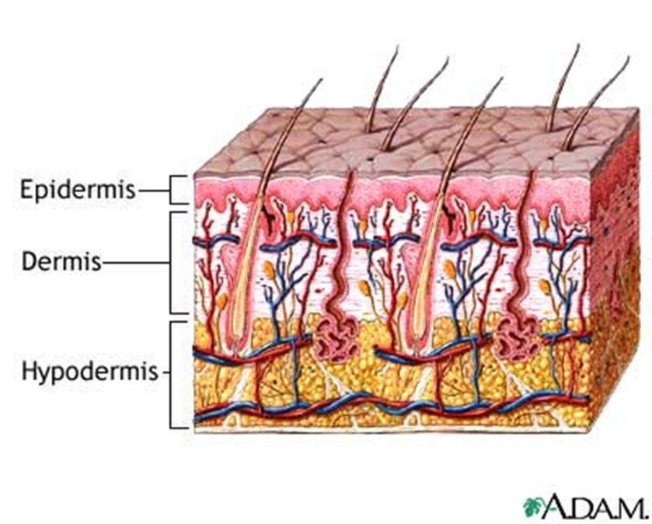
The three layers, and why the morphology definitions care about them. A lesion confined to the epidermis is superficial — that is an erosion, which stays moist and does not bleed. Reach the dermis , where the vessels run, and it can bleed and scar — that is an ulcer. A nodule sits deeper in the dermis than a papule, and a cyst may sit deeper still, in the subcutaneous layer. Source: PD II Derm - Beck.pptx, Slide 3.
Gland | Secretes | Notes
Sudoriferous (eccrine) | Sweat | Maintains body temperature
Apocrine | Pheromones | Becomes active during puberty
Sebaceous | Sebum | Surrounds the hair follicle; keeps hair and skin moist

Hair type | Character | Where
Vellus | Short, fine | Covers the body
Terminal | Coarse | Scalp, pubic, axillary, beard

2.2 · Objective b — The descriptive vocabulary
★ PROFESSOR EMPHASIS
★ Professor emphasized
This vocabulary is the backbone, not a glossary to skim. “This is what’s very important … this is going to be really important for every system that you learn within physical exam lab and physical exam lectures. These are going to be the backbone of how you write your notes and how you communicate to other providers.”
She is saying this section outlives dermatology — it is how you will describe findings in every organ system for the rest of the course.

Five features describe any lesion: distribution (location) · configuration (shape) · morphology (form and structure) · colour · texture.
Distribution — unilateral, bilateral, symmetric, asymmetric, photodistribution, intertriginous, flexural, extensor, palmar-plantar, hair-bearing areas. Distribution is often the fastest route to a diagnosis:
Distribution | Suggests
Generalised or diffuse | Allergic reactions
Regional (confined to one body area) | Tinea capitis
Sun-exposed (photodistribution) | Skin cancers
Dermatome | Herpes zoster
Extensor | Psoriasis
Flexor | Intertrigo
Intertriginous (creases and folds) | Involvement of skin folds

Configuration — the shape the lesions make together:
Term | Meaning
Annular | Shaped like a ring; round
Arciform | Forms arcs or curves
Confluent | Lesions run together
Discrete | Lesions remain separate
Grouped | A cluster of lesions
Gyrate | Twisted, coiled, spiral, snakelike
Herpetiform | Grouped papules or vesicles arranged as in herpes simplex
Iris (target) | Shaped like a bull's eye
Linear | Forms a line or stripe
Reticular | Lacy or networked pattern
Serpiginous | Snake-like
Zosteriform | Clustered in a dermatomal distribution, as in herpes zoster

The pair most often confused: herpetiform is grouping like herpes simplex; zosteriform is a dermatomal band like herpes zoster. Both are named for an infection, which is what makes them easy to swap.

2.3 · Objective b — Primary morphology
★ PROFESSOR EMPHASIS
★ Professor emphasized — and a cross-course warning
Beck uses ONE CENTIMETRE as the macule/patch boundary. “A macule is less than one centimeter, it is a flat discoloration — that’s important. A patch is going to be a flat discoloration that’s more than one centimeter. Okay? That’s important.”
Clinical Pathophysiology teaches five millimetres for the same lesions, and Professor Gopal said her numbers are the ones her exam uses. Both lectures ran on 2026-08-18, three hours apart. Neither is wrong — they are different conventions, and each course examines its own. Use one centimetre here and five millimetres there.
Neither of them will ask a borderline case. Beck: “My exam question is not going to involve this … I’m not going to ask you ‘it’s point seven five centimetres’ … so it’s going to be very clear.” Gopal, the same day: “it’s not gonna be a gotcha thing on the exam.” Know the numbers — they are fair game. What neither of them will do is make a borderline value the crux of the question, so you will not be asked to call a 0.75 cm lesion. Learn the boundaries; do not agonise over the edge cases.

A primary lesion forms first and results directly from the disease. Identifying it is the key to interpretation and description — every later description depends on getting this right.
One centimetre is the hinge. Four of the definitions below turn on it, in matched pairs: flat under and over (macule / patch), solid elevated under and over (papule / plaque), fluid-filled under and over (vesicle / bulla). Learn the three pairs and you have six of the terms. Bring a ruler — that is why one is on the equipment list.
Lesion | Definition | Size | Example
Macule | Circumscribed, flat discoloration — brown, blue, red or hypopigmented | < 1 cm | Freckles
Patch | Circumscribed, flat discoloration; a large macule, or macules that coalesce | > 1 cm | Vitiligo, café au lait spots
Papule | Palpable, elevated solid mass | < 1 cm | Nevi, warts, lichen planus
Plaque | Palpable, elevated solid mass, plateau-like; elevated, flat-topped, firm, rough; occupies a large area compared with its elevation; may be coalesced papules | > 1 cm | Psoriasis
Nodule | Elevated, firm, circumscribed; round or ellipsoid; deeper in the dermis than a papule | 1–2 cm (Bates says larger than 0.5 cm) | Basal cell carcinoma, neurofibromatosis
Tumor | Palpable, elevated solid mass | > 2 cm | Neoplasms
Wheal | Elevated irregular-shaped area of cutaneous edema; solid, transient | Variable | Allergic reaction
Vesicle | Superficial elevation filled with fluid | < 1 cm | Blister, herpes simplex
Bulla | Superficial elevation filled with fluid | > 1 cm | Large blister
Pustule | Superficial elevation filled with purulent material | Usually < 1 cm | Acne, impetigo
Cyst | Elevated, circumscribed, encapsulated; in the dermis or subcutaneous layer; liquid or semisolid contents | — | Sebaceous cyst

Two lesions are defined by something other than size. A wheal is the only transient one — if it is gone by the next visit, that is the finding, not a missed examination. A cyst is the only encapsulated one, which is what separates it from a nodule you can feel at the same depth.
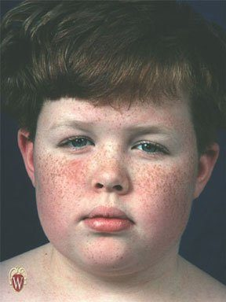  Macules — freckles. Circumscribed, flat discoloration under one centimetre. Run a finger across them and you feel nothing; that is what makes them macules rather than papules. Source: PD II Derm - Beck.pptx, Slide 32. | 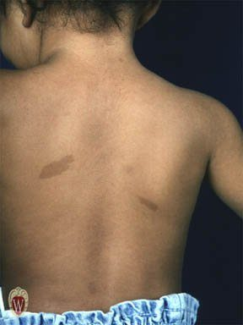  Patches — café au lait spots. The same flat discoloration as a macule, but larger than one centimetre. A patch may also be several macules that have coalesced. Source: PD II Derm - Beck.pptx, Slide 33. | 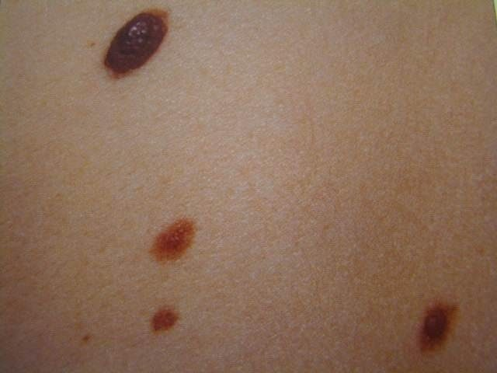  Papules — nevi. Palpable, elevated, solid, under one centimetre. Elevation is the whole distinction from a macule, and it is found by touch rather than by looking. Source: PD II Derm - Beck.pptx, Slide 34.
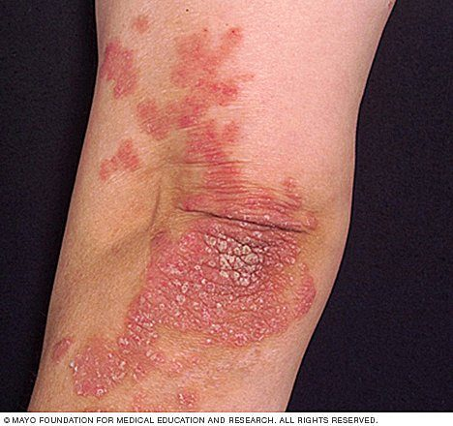
Plaques — psoriasis. Elevated, flat-topped, firm and rough, larger than one centimetre, and occupying a large area compared with how far they rise. Note the extensor location: distribution and morphology are pointing at the same diagnosis. Source: PD II Derm - Beck.pptx, Slide 35.

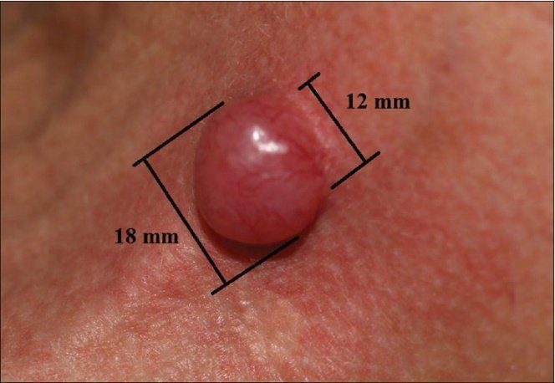  A nodule , measured. Elevated, firm, circumscribed, round or ellipsoid, and sitting deeper in the dermis than a papule. This is why a ruler is on the equipment list — at eighteen millimetres this is a nodule, and at over twenty it would be a tumor. Source: PD II Derm - Beck.pptx, Slide 36. | 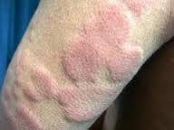  Wheals — an allergic reaction. Elevated, irregular areas of cutaneous edema: solid, of variable diameter, and the only primary lesion that is transient . If it has gone by the next visit, that is the finding rather than a missed examination. Source: PD II Derm - Beck.pptx, Slide 37. | 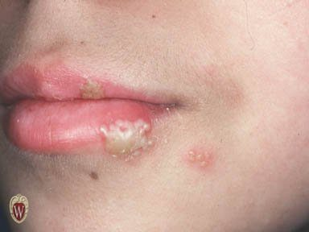  Vesicles — herpes simplex. Superficial elevations filled with fluid, under one centimetre. The grouping is worth naming too: papules or vesicles clustered like this are described as herpetiform . Source: PD II Derm - Beck.pptx, Slide 39.
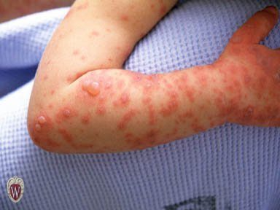
Bullae . The same superficial fluid-filled elevation as a vesicle, over one centimetre. Size is the only thing separating the two terms. Source: PD II Derm - Beck.pptx, Slide 40.

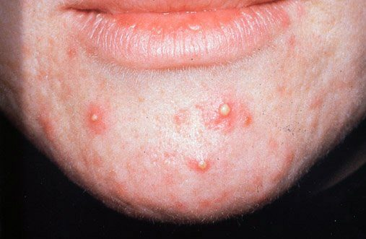  Pustules — acne. Superficial elevations filled with purulent material, usually under one centimetre. Contents are what separate a pustule from a vesicle, not size. Source: PD II Derm - Beck.pptx, Slide 41. | 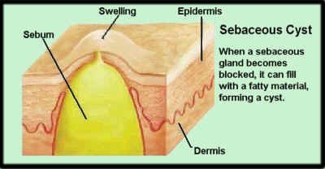  A cyst — elevated, circumscribed and encapsulated , sitting in the dermis or subcutaneous layer and filled with liquid or semisolid material. The capsule is the distinguishing feature; a nodule at the same depth has none. Source: PD II Derm - Beck.pptx, Slide 42.

2.4 · Objective b — Secondary morphology
A secondary lesion is a change in a primary lesion over time — from disease progression, from treatment, or from manipulation such as picking or scratching. That third cause is worth holding on to: the patient's own hands change the examination.
Lesion | Definition | Example
Crust | Collection of cellular debris, dried serum and blood — a scab. The antecedent primary lesion is usually a vesicle, bulla or pustule | —
Erosion | Loss of superficial epidermis, does not involve dermis; surface is moist but does not bleed | The moist area after a bulla or vesicle ruptures
Ulcer | Deeper loss of epidermis and/or dermis; may bleed and scar | Stasis ulcer of venous insufficiency
Fissure | Linear crack in skin | Athlete's foot
Scale | Thin flake of exfoliated epidermis | Dandruff, cradle cap
Excoriation | An abrasion or scratch mark; may be linear or rounded | Scratched insect bite
Scar (cicatrix) | Replacement of destroyed tissue by fibrous tissue. Thick and pink (hypertrophic) or thin and white (atrophic); does not extend beyond the injured area | —
Keloid | Scar that grows beyond the wound | —
Lichenification | Thickening with skin line accentuation; roughening and thickening of epidermis; caused by chronic irritation | Atopic dermatitis
Collarette scale | Fine scale, peripherally attached and centrally detached, on the edge of an inflammatory lesion | Pityriasis rosea

Erosion versus ulcer is the discrimination worth being certain about: an erosion stops at the epidermis, is moist, and does not bleed or scar; an ulcer reaches the dermis, may bleed, and may scar. Depth determines all three consequences at once.
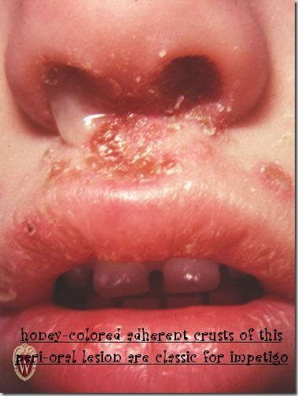  Crust — the honey-coloured adherent crusting of impetigo. Cellular debris, dried serum and blood: a scab. Work backwards from it, because the antecedent primary lesion is usually a vesicle, bulla or pustule. Source: PD II Derm - Beck.pptx, Slide 43. | 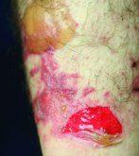  Erosion — the moist area left after a bulla or vesicle ruptures. Loss of superficial epidermis only: the surface is moist but does not bleed , because the dermis has not been breached. Source: PD II Derm - Beck.pptx, Slide 44. | 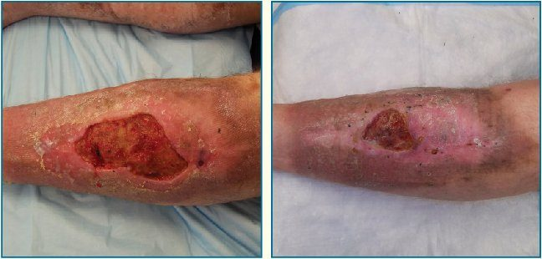  Ulcer — a stasis ulcer of venous insufficiency, shown before and after healing. Deeper loss of epidermis and dermis, so it may bleed and it may scar. Depth decides all three consequences at once. Source: PD II Derm - Beck.pptx, Slide 45.
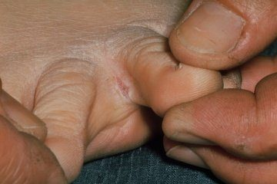
Fissure — a linear crack in the skin, here between the toes in athlete's foot. Same site as tinea pedis on the infection slide, which is not a coincidence. Source: PD II Derm - Beck.pptx, Slide 46.

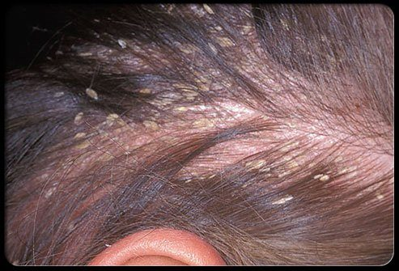  Scale — thin flakes of exfoliated epidermis. Distinguish it from crust by what it is made of: scale is shed epidermis, crust is dried serum, blood and debris. Source: PD II Derm - Beck.pptx, Slide 47. | 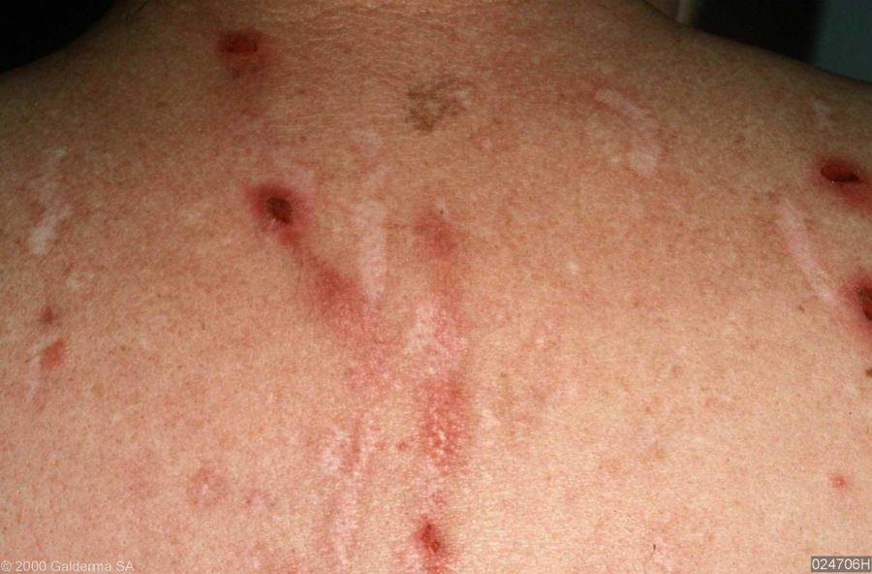  Excoriations — abrasions or scratch marks, which may be linear or rounded. This is the secondary lesion caused by manipulation rather than by the disease, and it tells you the eruption itches. Source: PD II Derm - Beck.pptx, Slide 48. | 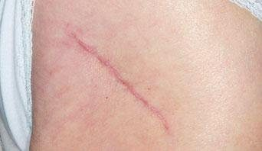  A scar — fibrous tissue replacing destroyed tissue. Thin and pale is atrophic, thick and pink is hypertrophic, and either way a scar does not extend beyond the injured area . That last clause is what separates it from a keloid. Source: PD II Derm - Beck.pptx, Slide 49.
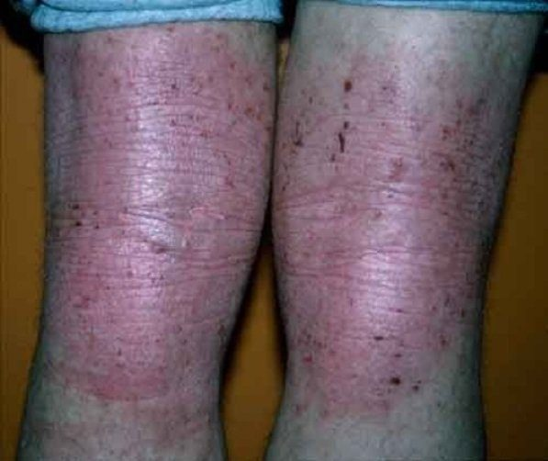
Lichenification — thickening with skin line accentuation , from chronic irritation in atopic dermatitis. The exaggerated creases are the finding. Note the flexural distribution, and the excoriations that explain the mechanism. Source: PD II Derm - Beck.pptx, Slide 52.

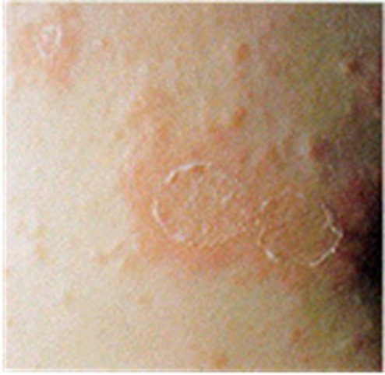
Collarette scale — pityriasis rosea. Fine scale attached at the periphery and detached at the centre , sitting on the edge of an inflammatory lesion. Which end is attached is the entire definition. Source: PD II Derm - Beck.pptx, Slide 53.

Also worth knowing | Detail
Verrucae (warts) | Caused by human papillomavirus. Small harmless tumors of the skin; grey to flesh coloured nodules raised from the surface, sometimes with rough hornlike projections
Corn | Smaller than a callus; usually over a non-weight-bearing area of the foot; conical structure of keratin pointing toward the dermis
Callus | Thickening of epidermal keratin; usually on the sole of the foot, at the ball or heel

2.5 · Objective c — The dermatological history
The five core questions: where did the problem first appear · what did it look like · how has it progressed or changed · any associated symptoms · what treatment has been tried.
Think bugs, drugs, contact. Three exposure categories, and the fastest way to remember what else to ask: bugs — family members or contacts with the same, travel; drugs — systemic medications, both over-the-counter and prescription; contact — allergens and irritants from hobbies, occupation and environment.
Area | What to ask
Existing skin abnormalities | Changes in colour · changes in shape (border, elevation, diameter) · changes in size · pain · bleeds easily · non-healing areas
Onset | Duration; acute versus chronic
Relationships | Season, travel history, heat or cold, previous reactions, drugs, menses
Skin symptoms | Pruritus, pain, paresthesia
Past medical history | Previous problems; systemic disease; personal dermatology history including disease and surgery
Family history | Skin cancer, psoriasis, allergies, infestations, infections
Psychosocial | Personal habits, exposures. Psychological stress is seldom the sole cause but can exacerbate many dermatoses

NOTE
Pruritus is not a diagnosis. It is the sensation that causes the desire to scratch. Generalised itching with no obvious reason has a wide differential — dry skin, ageing, pregnancy, uremia, jaundice, lymphomas, leukemias, drug reaction and lice. Other sensations to ask about: burning, pain or tenderness, tingling, a creeping or crawling feeling, and whether it is intermittent or continuous.

Patients with cognitive problems may not attend to hygiene. If the hygiene of the skin, hair or nails appears inadequate, that is a finding — assess the social history, cognition, and ability to perform activities of daily living.

2.6 · Objective d — Abnormal findings: the skin
★ PROFESSOR EMPHASIS
★ Professor emphasized
The pressure ulcer stages. “These are very important. You’re gonna come across it.” She then walked stage one in full — intact skin, erythema that fails to blanch, and the four changes: temperature (warmth or coolness), consistency (firm or boggy), sensation (pain or itching), and colour.
The melanoma letters. “Things to look out for and to remember … you wanna remember the A, B, C, Ds … that’s really important.” She stopped and taught them from scratch when the class had not met them before.

Vascular lesions. The single manoeuvre that sorts them is diascopy: press a piece of clear glass or plastic against the skin and look at the lesion under pressure. If the colour fades, there is vascular engorgement; if it does not fade, it is hemorrhage in the skin.
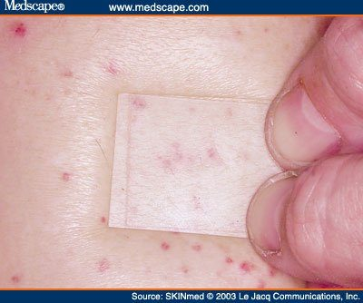
Diascopy. Press clear glass or plastic against the lesion and look at it under pressure. Here the spots persist under the glass — no blanching, so this is hemorrhage in the skin . Had the colour faded, it would be vascular engorgement instead. One manoeuvre, and it splits the whole vascular differential. Source: PD II Derm - Beck.pptx, Slide 55.
Lesion | Appearance | Size | Blanches?
Petechiae | Reddish-purple macules | < 3 mm | No
Purpura | Reddish-purple macules | 3 mm – 1 cm | No
Ecchymosis | Purple or purplish-blue macules, fade over time | > 1 cm | No
Cherry angioma (Campbell De Morgan spots) | Dome shaped, bright red to violet or black | — | Sometimes
Telangiectasia | Fine, irregular blood vessels | — | Yes
Spider angioma | Central red macule with radiating spider-like arms | — | Yes

Petechiae, purpura and ecchymosis are the same finding at three sizes, and none of them blanches — because the blood is outside the vessels. Under 3 mm, 3 mm to 1 cm, over 1 cm.
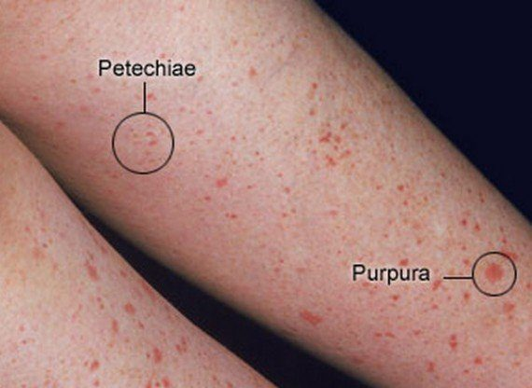  Petechiae and purpura on one leg, labelled. Same finding at two sizes: petechiae under three millimetres, purpura from three millimetres to one centimetre. Neither blanches. Over a centimetre and it becomes an ecchymosis. Source: PD II Derm - Beck.pptx, Slide 56. | 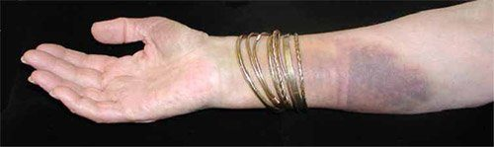  Ecchymosis — over one centimetre, purple to purplish-blue, non-blanching, and it fades over time as the extravasated blood breaks down. That evolution is what the other two do not do. Source: PD II Derm - Beck.pptx, Slide 57. | 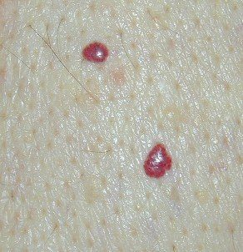  Cherry angiomas , also called Campbell De Morgan spots. Dome shaped, bright red to violet or black, and they may or may not blanch — which is why they sit awkwardly between the blanching and non-blanching groups and are best learned by their shape. Source: PD II Derm - Beck.pptx, Slide 58.

Dermatographism — “writing on skin”, an urticarial type allergic reaction. Firm stroking produces the triple response of Lewis:
Step | What appears | Mechanism
1 | Initial red line | Capillary dilatation
2 | Reflex flare with broadening erythema | Arteriolar dilatation
3 | Formation of a linear wheal | Transudation of fluid, that is, edema

Decubitus (pressure) ulcers. Staged by depth:
Stage | Finding
I | Alteration of intact skin: erythema that fails to blanch with pressure, plus change in temperature (warmth or coolness), consistency (firm or boggy), sensation (pain or itching), and colour
II | Partial thickness skin loss involving epidermis, dermis or both
III | Full thickness skin loss; necrosis of subcutaneous tissue; may extend to but not through underlying muscle
IV | Full thickness skin loss; destruction of tissue, muscle and/or bone

The stage I / stage II line is whether the skin is broken; the stage III / stage IV line is whether muscle and bone are destroyed. “Reaches muscle but does not go through it” is still stage III.
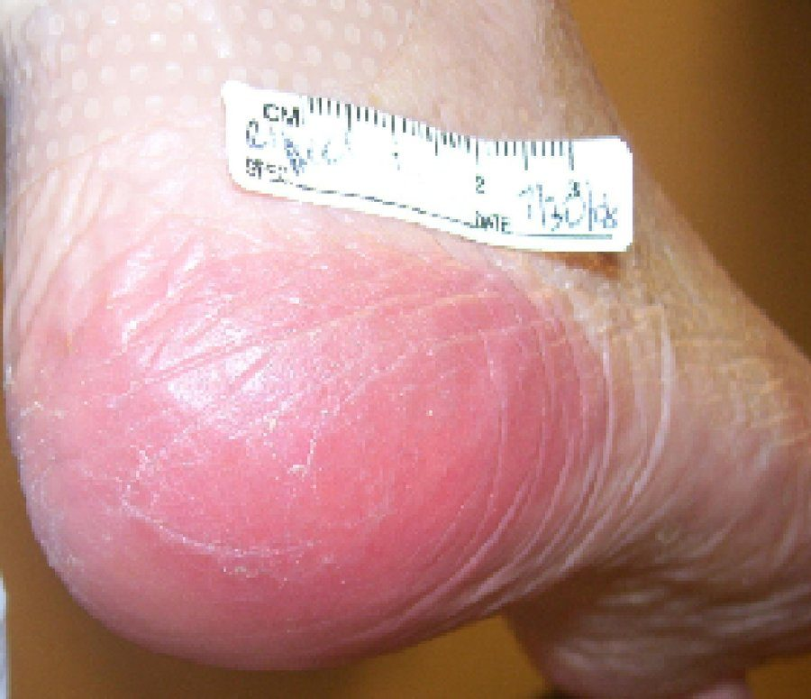  Stage I pressure ulcer. The skin is intact — the finding is erythema that fails to blanch under pressure, together with change in temperature, consistency, sensation and colour. Everything after this stage involves broken skin. Source: PD II Derm - Beck.pptx, Slide 59. | 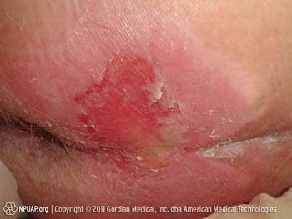  Stage II . Partial thickness skin loss involving epidermis, dermis or both. Shallow and open, with no necrosis of the tissue beneath. Source: PD II Derm - Beck.pptx, Slide 60. | 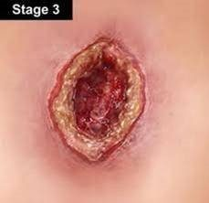  Stage III . Full thickness skin loss with necrosis of subcutaneous tissue. It may extend down to underlying muscle but not through it — reaching muscle without destroying it is still stage III. Source: PD II Derm - Beck.pptx, Slide 61.
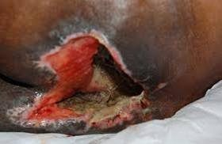
Stage IV . Full thickness loss with destruction of tissue, muscle and/or bone. Involvement of muscle and bone is the line between this and stage III. Source: PD II Derm - Beck.pptx, Slide 62.

Tinea infections, named by site: corporis (body) · pedis (foot) · barbae (beard) · cruris (groin) · capitis (scalp) · unguium (nails).
Infection | Appearance
Tinea pedis | Dry, scaling, or macerated fissuring of the interdigital spaces of the feet
Tinea corporis | Scaling, sharply demarcated round plaques with central clearing
Tinea capitis | Round scaling patches of alopecia with hairs broken off close to the scalp

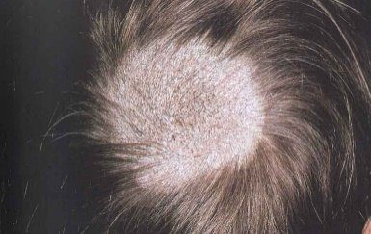  Tinea capitis — a round scaling patch of alopecia with hairs broken off close to the scalp. Both features matter: alopecia areata gives smooth patches with no scale, and trichotillomania gives neither. Source: PD II Derm - Beck.pptx, Slide 64. | 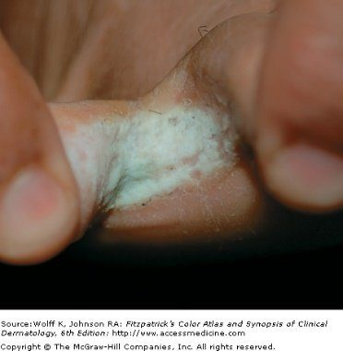  Tinea pedis — macerated fissuring of the interdigital spaces. It also presents dry and scaling; the web spaces are the constant. Source: PD II Derm - Beck.pptx, Slide 64. | 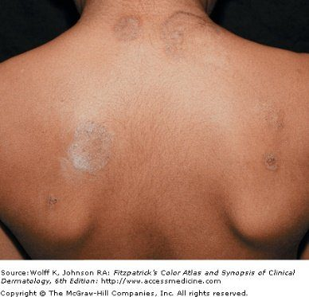  Tinea corporis — scaling, sharply demarcated round plaques with central clearing . The active advancing edge with a quiet middle is what earns it the name ringworm, and the configuration term for it is annular . Source: PD II Derm - Beck.pptx, Slide 64.

Malignancies of the skin.
Malignancy | Common site | Appearance
Basal cell carcinoma | Face | Translucent, pearly nodule with a depressed center and raised borders; may ulcerate. A non-healing ulcer is the other presentation
Squamous cell carcinoma | Face and other sun-exposed areas | Red scaling, crusting nodule or plaque that can ulcerate and bleed
Malignant melanoma | Changing nevi | Irregularly coloured plaque with sharp notches and variation of pigment
Kaposi's sarcoma | Widely disseminated — legs, trunk, arms, neck, head | Starts as light coloured lesions that coalesce into darker ones; dark blue-purple macules, papules, nodules and plaques. The most frequent neoplasm in patients with acquired immunodeficiency syndrome

Letter | Melanoma warning sign
A | Asymmetry or shape
B | Border irregularity
C | Colour variation
D | Diameter larger than 6 mm
E | Evolving, elevation
F | Family history
G | Growing

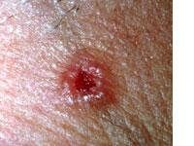  Basal cell carcinoma — a translucent, pearly nodule with a depressed centre and raised borders . The face is the common site. A non-healing ulcer there should raise the same suspicion even without the pearly rim. Source: PD II Derm - Beck.pptx, Slide 67. | 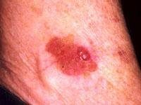  Squamous cell carcinoma — a red scaling, crusting nodule or plaque that can ulcerate and bleed. Face and other sun-exposed areas. Compare the surface with basal cell carcinoma: scaling and crusted here, translucent and pearly there. Source: PD II Derm - Beck.pptx, Slide 69. | 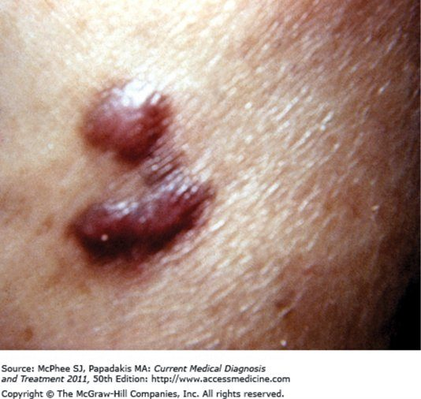  Kaposi's sarcoma — dark blue-purple macules, papules, nodules and plaques. Lesions start light coloured and coalesce into darker ones, and they are widely disseminated across legs, trunk, arms, neck and head. The most frequent neoplasm in patients with acquired immunodeficiency syndrome. Source: PD II Derm - Beck.pptx, Slide 74.

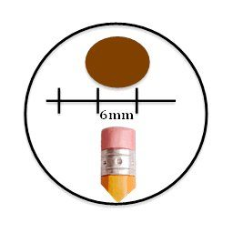  The D in the melanoma warning signs: diameter larger than six millimetres , which is about the width of a pencil eraser. The full list runs A asymmetry, B border irregularity, C colour variation, D diameter, E evolving or elevation, F family history, G growing. Source: PD II Derm - Beck.pptx, Slide 71. | 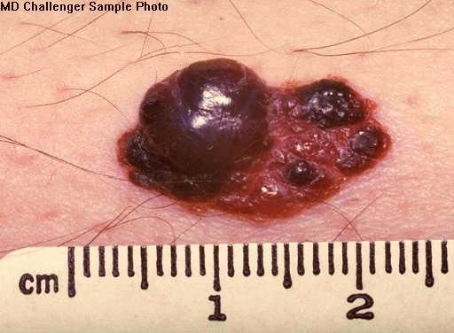  Malignant melanoma , with a ruler for scale. Every letter is visible at once: asymmetric, notched irregular border, marked variation in pigment, and well beyond six millimetres. Compare it against the changing nevus the history should have flagged. Source: PD II Derm - Beck.pptx, Slide 72.

2.7 · Objective d — Abnormal findings: hair and nails
★ PROFESSOR EMPHASIS
★ Professor emphasized
Exclamation point hairs in alopecia areata. “Hair loss in multiple round patchy areas, and this is important — you’ll see exclamation point hairs. Those are like a few follicles that are still trying … that should trigger in your mind, oh okay, alopecia areata, we gotta jump on this.”

Hair disorder | Findings
Alopecia | Diffuse, patchy or total hair loss. Note the distribution on inspection — that is what separates the causes
Androgenic alopecia | Male pattern baldness
Alopecia areata | Chronic inflammatory disease of hair follicles, associated with autoimmune disorders. Hair loss in multiple round patches, with “exclamation point” hairs
Trichotillomania | Caused by an urge to pull out hair, producing bald patches. Single or multiple; from a few square centimetres to the entire scalp
Hirsutism | Increased hair growth in women, in a male pattern of distribution
Lice | Tiny white ovoid granules — nits — adherent to hairs. A magnifying glass aids inspection

Three causes of patchy hair loss, told apart by what is left behind: tinea capitis leaves scaling patches with hairs broken close to the scalp; alopecia areata leaves smooth patches with exclamation point hairs; trichotillomania leaves patches from pulling, with neither scale nor exclamation point hairs.
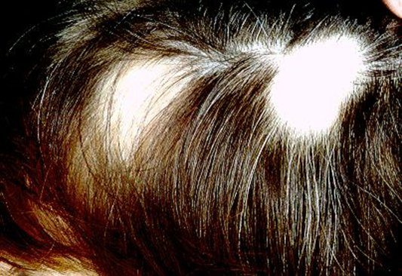
Alopecia areata — hair loss in multiple round patches. The scalp is smooth , with no scale, which separates it immediately from tinea capitis. Look at the margins for the tapered “exclamation point” hairs. It is a chronic inflammatory disease of the hair follicles and is associated with autoimmune disorders. Source: PD II Derm - Beck.pptx, Slide 79.
Nails. Inspect for shape, size, colour, brittleness, hemorrhages, lines and grooves, clubbing, and pitting.
Finding | Description | Points toward
Koilonychia | Spoon-shaped concave nails; the nail plate thins and becomes inverted | —
Onycholysis | Painless separation of nail plate from nail bed, starting distally; several or all nails usually affected | Local irritation (chemical exposure, prolonged immersion in water), fungal infection, psoriasis, medications such as tetracycline, trauma
Nail pitting | Dystrophy of the nail plate; areas of small depressions or “pits” | —
Terry's nails | Proximal portion white, distal portion dark | —
Green nail | — | Pseudomonas infection
Brown–black nail | — | Melanoma
Subungual hematoma | Hemorrhage to the nail plate | —
Splinter hemorrhages | Hemorrhage of the distal capillary loop | —
Beau's lines | Transverse depressions | Halfway up the nail suggests an illness about 3 months ago
Mee's lines | Transverse lines | —
Clubbing | Angle between nail base and finger greater than 180°; end of finger becomes rounded and bulbous | —
Paronychia | Soft tissue infection around the nail, at the cuticle or nail fold. Acute: painful and purulent. Also occurs in chronic form | —

Beau's lines are a clock. The nail grows out at a roughly known rate, so a transverse depression halfway up dates the insult to about three months before the visit — which is the sort of finding that sends you back to the history with a specific date in mind.
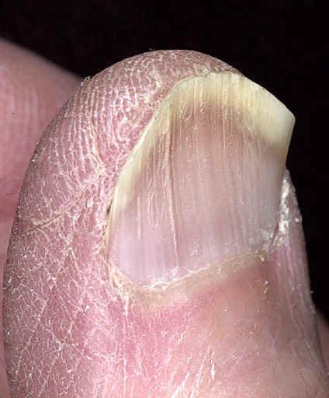  Koilonychia — spoon-shaped concave nails. The nail plate thins and becomes inverted; the concavity can be deep enough to hold a drop of water. Source: PD II Derm - Beck.pptx, Slide 85. | 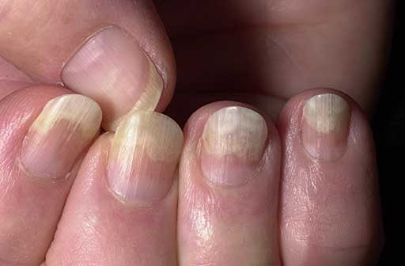  Onycholysis — painless separation of the nail plate from the bed, beginning distally and enlarging the free edge. Several or all nails are usually affected. Causes span local irritation, fungal infection, psoriasis, tetracycline and trauma. Source: PD II Derm - Beck.pptx, Slide 86. | 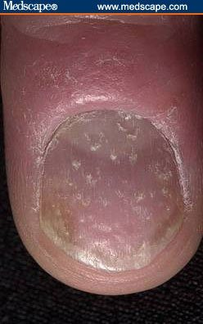  Nail pitting — dystrophy of the nail plate producing small depressions. Worth pairing in your head with onycholysis, since psoriasis produces both. Source: PD II Derm - Beck.pptx, Slide 87.
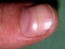
A transverse nail change. Beau's lines are transverse depressions you can feel; Mee's lines are transverse lines of colour. Beau's lines date the insult — halfway up the nail corresponds to an illness about three months before the visit. Source: PD II Derm - Beck.pptx, Slide 90.

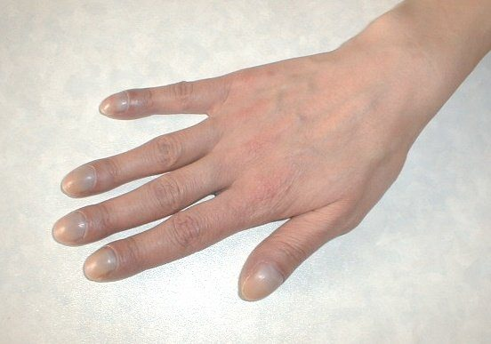  Clubbing — the angle between nail base and finger exceeds one hundred and eighty degrees , and the end of the finger becomes rounded and bulbous. Sight the finger from the side; the angle is the measurable part rather than the impression of bulbousness. Source: PD II Derm - Beck.pptx, Slide 91. | 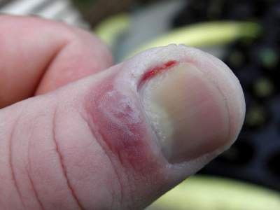  Acute paronychia — soft tissue infection around the cuticle or nail fold, painful and purulent. There is a chronic form too; pain and pus are what mark this one as acute. Source: PD II Derm - Beck.pptx, Slide 92.

2.8 · Objective e — Performing the examination
★ PROFESSOR EMPHASIS
★ Professor said you do NOT need this
Clinical pearls are context, not exam material. After explaining that shingles on the tip of the nose is a medical emergency because that dermatome carries the optic nerve, she drew the line explicitly: “I’m not going to test you on that — the testing is on this kind of stuff — but I’m just trying to give you the clinical level.”
“This kind of stuff” is the descriptive terminology and the examination itself. She added the pearl is worth knowing anyway because she believes it recurs on board exams — so learn it for practice, not for this exam.

The four principles are inspection, palpation, percussion and auscultation. That order holds for every body system except the abdominal examination, and some systems do not use all four.
Set-up | Detail
Equipment | Ruler · light source · magnifying lens · gloves for any open lesions
Patient | In a gown — so that hair, anterior and posterior body surfaces, palms and soles, nails and interdigital spaces can all be inspected
Light | Inspect the entire skin surface in good light, preferably natural light or artificial light that resembles it. Artificial light may distort skin tone

Six characteristics are assessed by inspection, palpation, or both:
Characteristic | Descriptive terms
Colour | Increase or decrease in pigmentation · erythema/rubor · pallor · jaundice · cyanosis
Moisture | Dryness · sweating · oiliness
Temperature | Warmth · coolness — use the dorsal aspect of the hands
Texture | Roughness · smoothness
Mobility and turgor | See below
Lesions | Distribution, configuration, morphology, colour, texture

 | Normal | Abnormal
Mobility | Skin lifts up with ease | Edema — reduced skin mobility
Turgor | Skin quickly resumes its shape | Dehydration — skin remains elevated

Central versus peripheral cyanosis is a two-organ distinction. Central cyanosis is often due to inadequate oxygenation in the lungs; peripheral cyanosis is usually due to inadequate circulation. Same colour, different organ.
Hair and scalp. Inspect colour, distribution and quantity; palpate for texture. Separate the hair into sections to observe the scalp, and inspect behind the ears and the occiput. The scalp should be clean, with no lesions, discolorations, flaking or parasites.
Source: PD II Derm - Beck.pptx (Valerie Beck, DMSc, PA-C), Slides 1–103, and the PAJ 5310 syllabus instructional objectives. Course texts: Bickley, Bates' Guide to Physical Examination and History Taking; Wolff & Johnson, Fitzpatrick's Color Atlas & Synopsis of Clinical Dermatology. All 43 figures are reproduced from the lecture slides and each is cited to the slide it came from.

